Correction Entry Module

( If once Card is generated for a particular year and we have to change that data, the modification on the data should be saved as Correction entry will be displayed in the current years Card with interest from that pertaining year itself..)

- Modification can be occurred in Chalan / Schedule
  - Change in Chalan date
    - Affected transactions of all employees in that Chalan from that date.
- Modification can be occurred in Schedule
  - Change in account no. (Affected 2 employees)
    - New account no. (Add amount with interest)
    - Delete account no.. . (Subtract amount with interest)

  - Change in amount of a particular employee
    - Change in amount for that employee
- Delete one Acc No.
- Add one Acc No.

- Change in Bill date
  - Affected transactions of all employees in that Chalan from that date
- Change in account no. (Affected 2 employees)
  - New account no. (Add amount with interest)
  - Delete account no.. . (Subtract amount with interest)
- Change in amount of a particular employee
  - Change in amount for that employee
- Delete one Acc No.
- Add one Acc No.

Correction Entry Module Calculation

Change in Interest Rate

- A modification in DB design due to change in interest rate for the year 2011-12 (April- Oct 8.6 and Nov- March 8.8)
- Change in Credit Card and Ledger reports

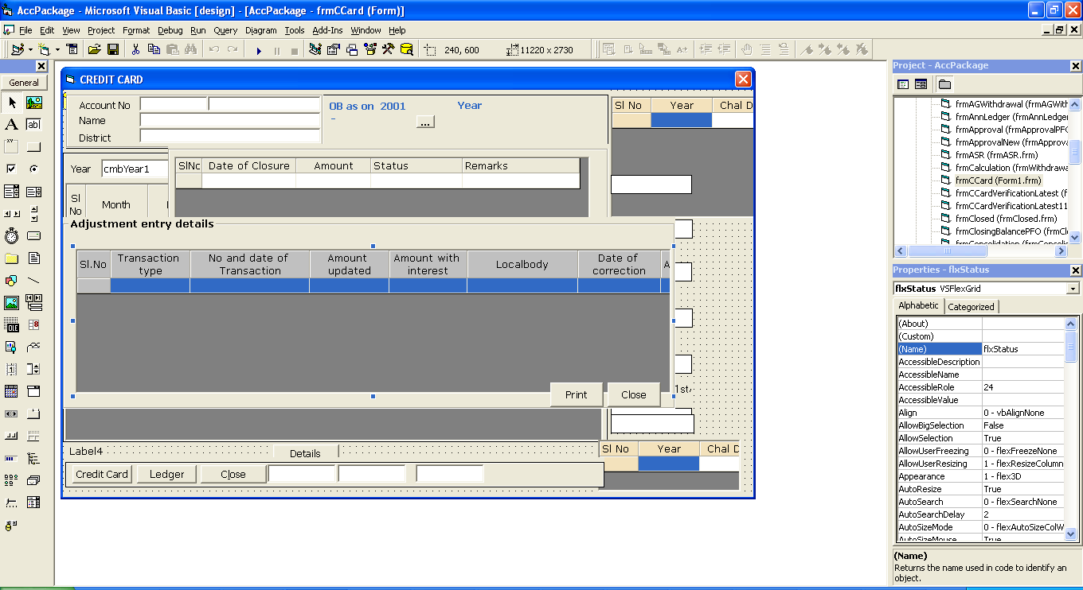

Reconciliation Module

Annual Accounts Statement
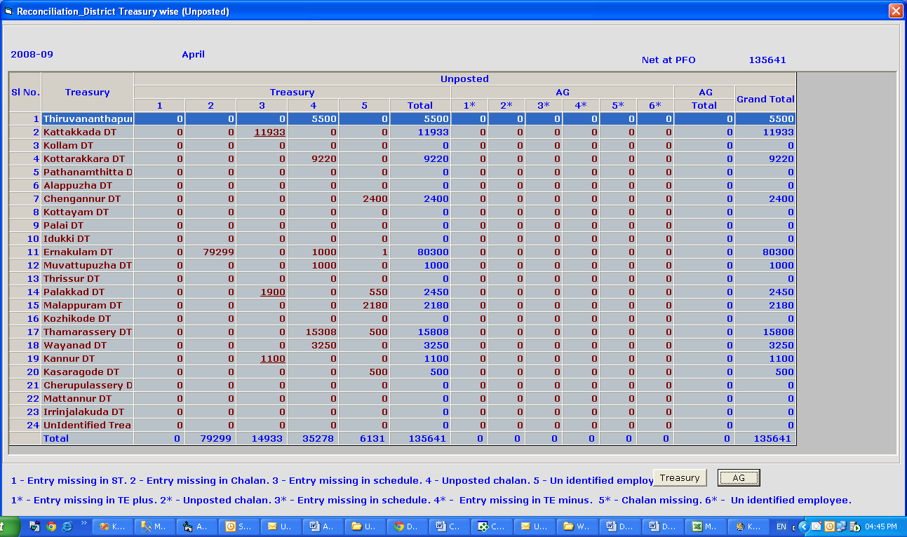

Year wise process of calculation

2008-09 Posted Only

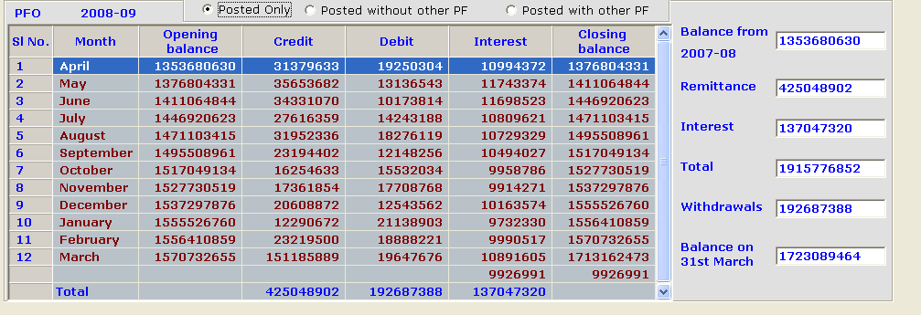

2008-09 Posted without Other PF

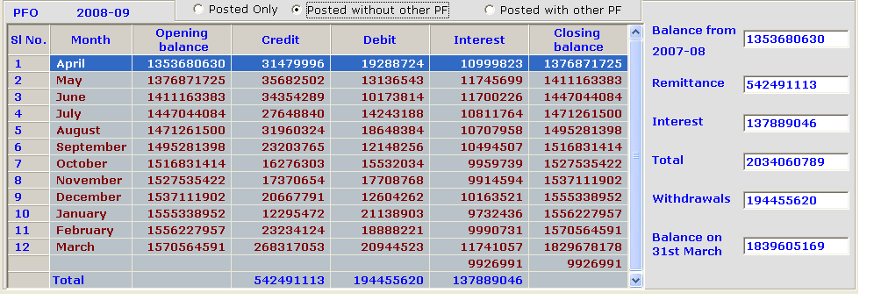

2008-09 Posted with Other PF
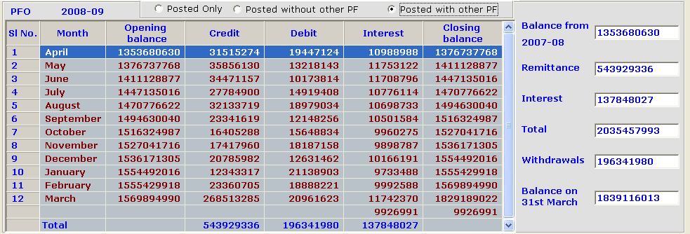

2009-10 Posted Only

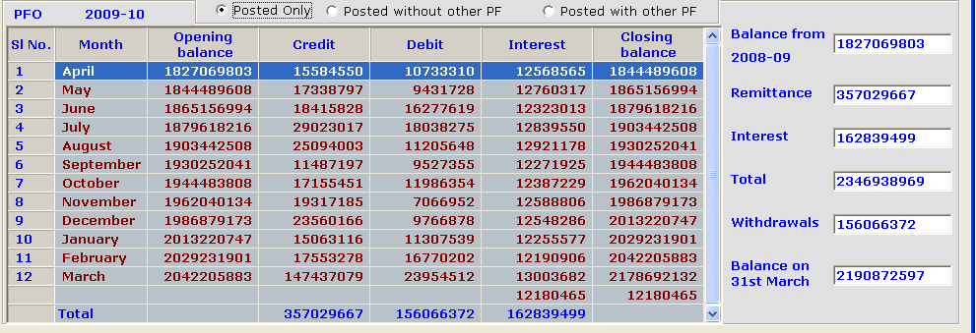

2009-10 Posted without Other PF
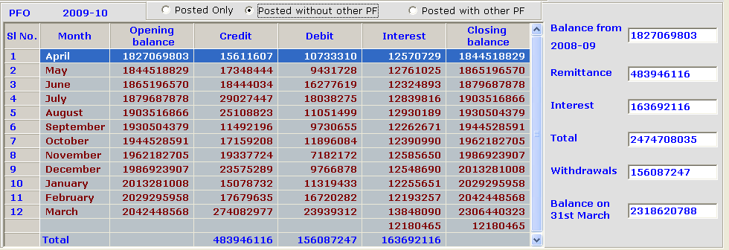

2009-10 Posted with Other PF
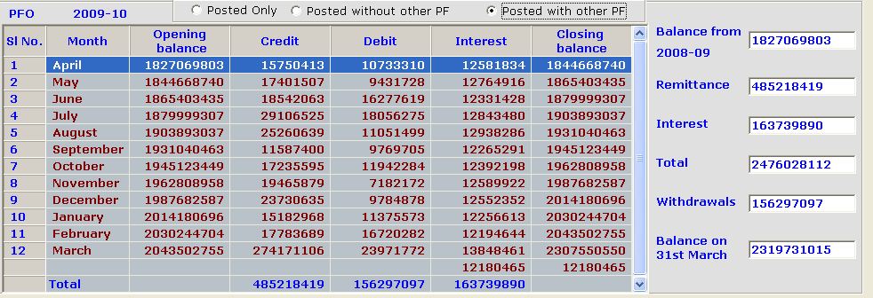

2010-11 Posted Only
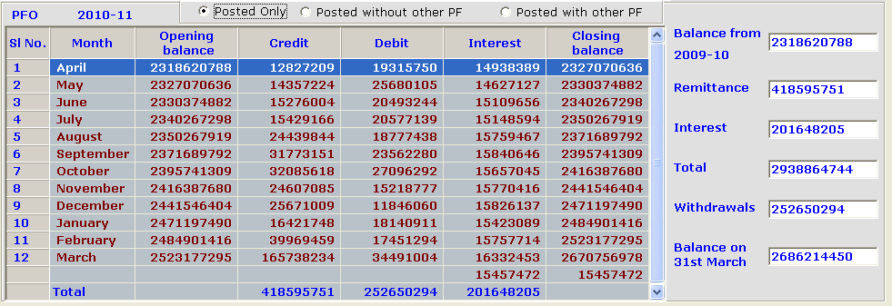

2010-11 Posted without Other PF
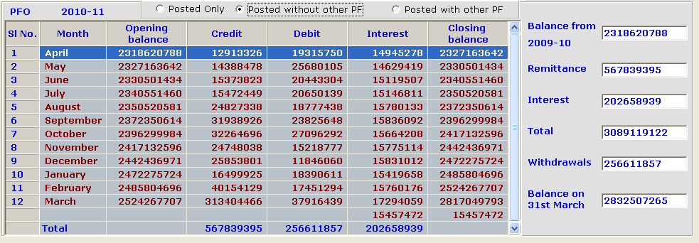

2010-11 Posted with other PF
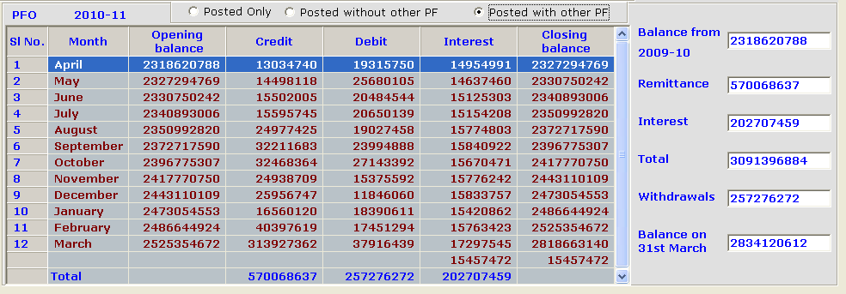

2011-12 Posted Only

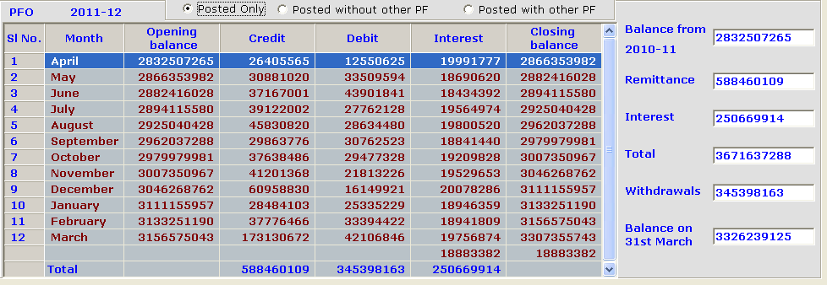

2011-12 Posted without other PF
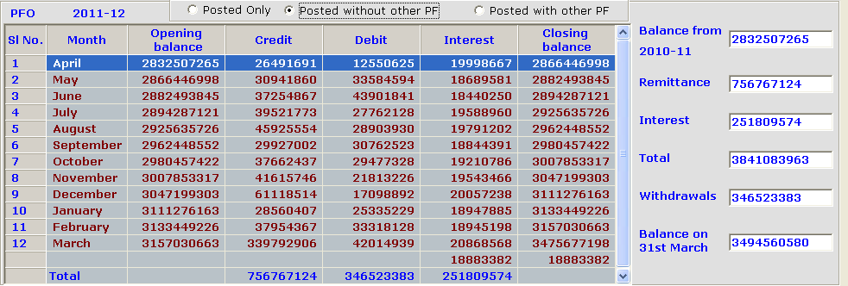

2011-12 Posted with other PF

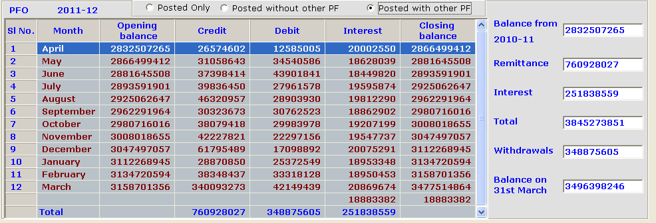

Year Wise Details (Treasury AG Reconciliation Process)

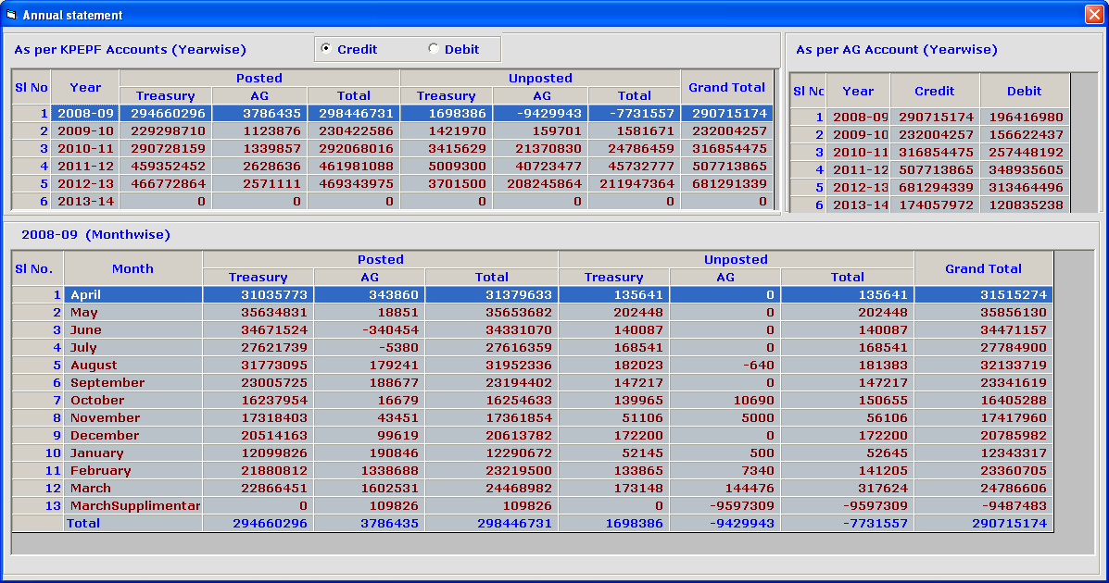
Reconciliation DistrictTreasury Wise

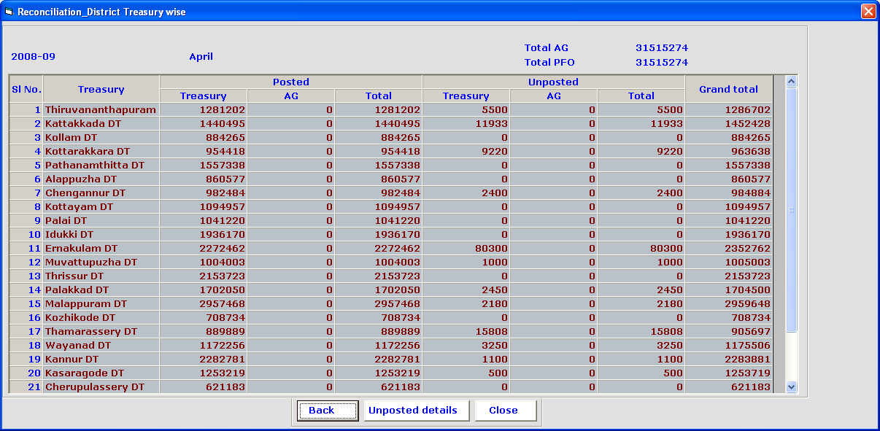

Reconciliation –(DT wise Unposted details)

